*LAB # 01*

introduction to linux operating sysytem

# *OBJECTIVE:*

*To study the Execution of various file/directory handling command*

*LAB task*

*1. Create multiple directories and subdirectories.*

* ***Mkdir(Make directory) :***

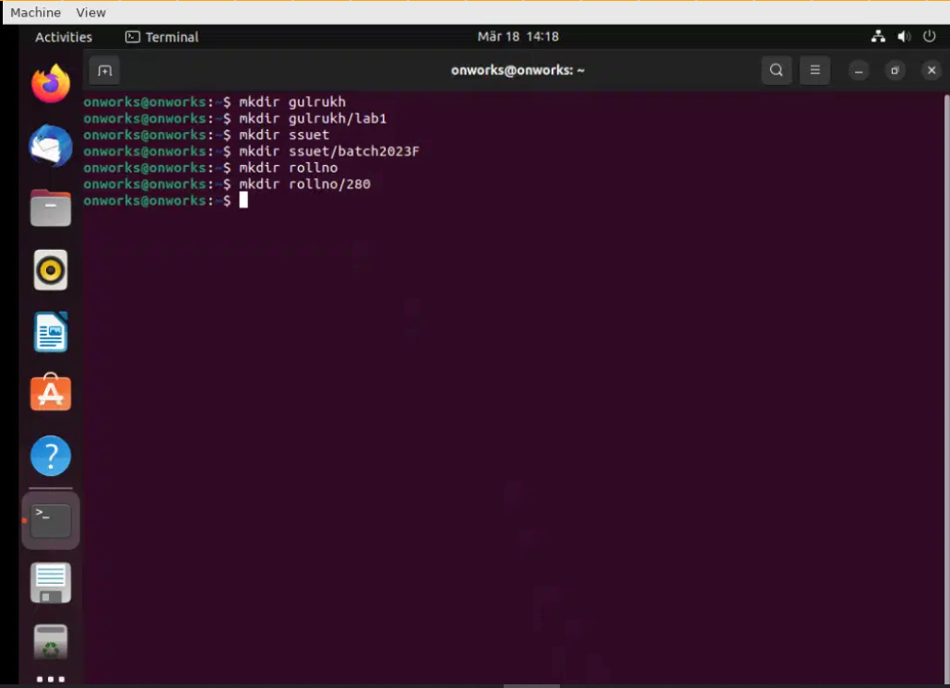

*2. Using man command(manual), explore atleast 5 extensions of each command i.e. rmdir, mkdir, ls and pwd. Implement them in any directory and insert screenshot*

* ***Ls (command for listing) :***

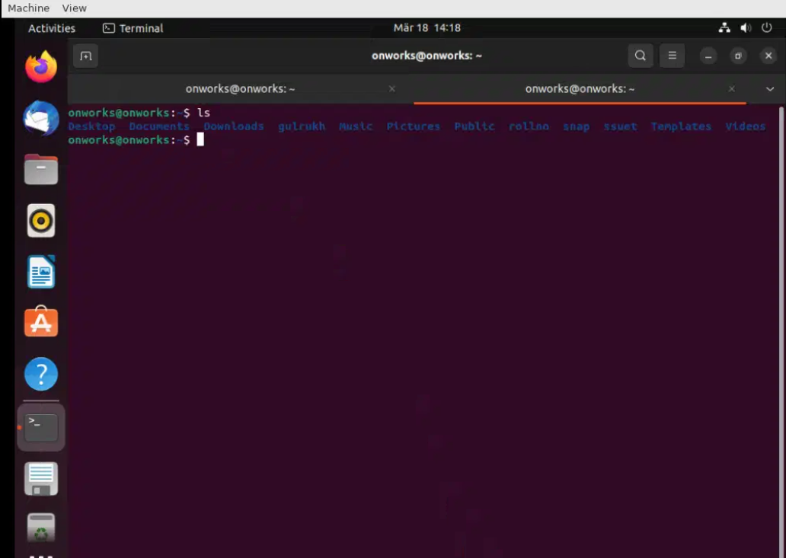

* ***Cd (change directory):***

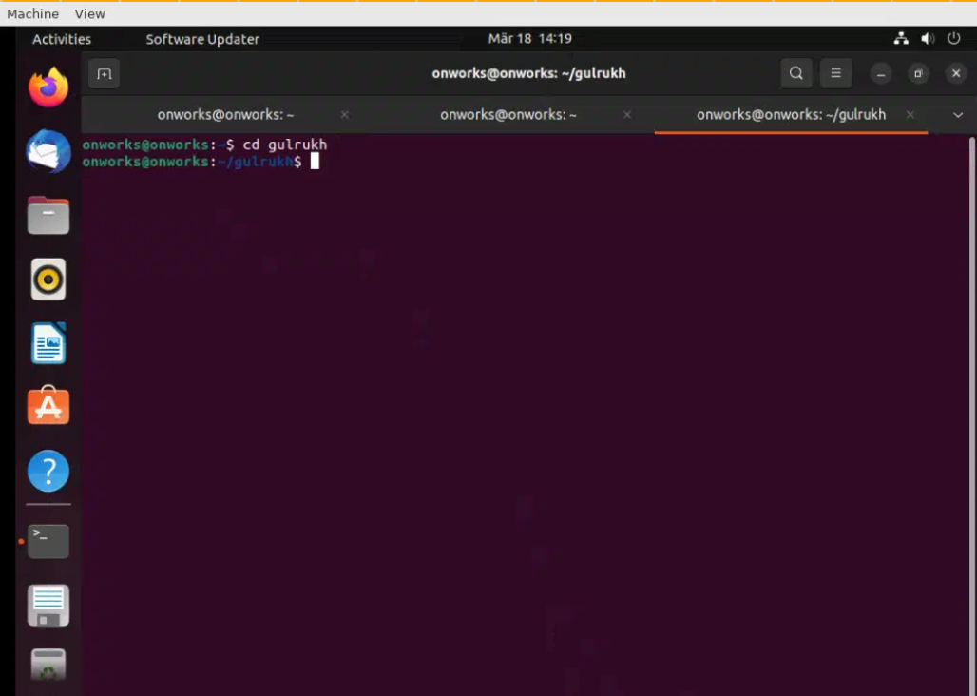

* ***Pwd (print working directory) :***

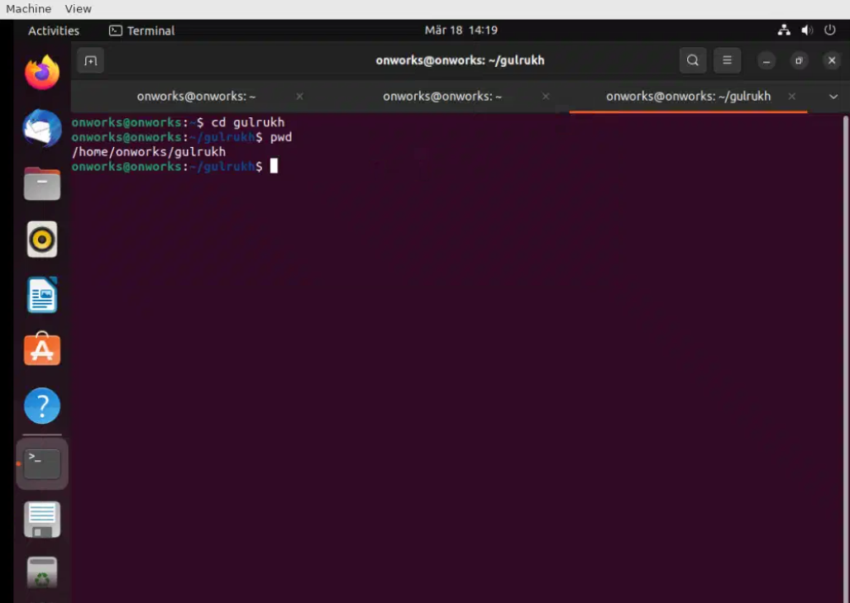

* ***After changing directory again see the list of directory :***

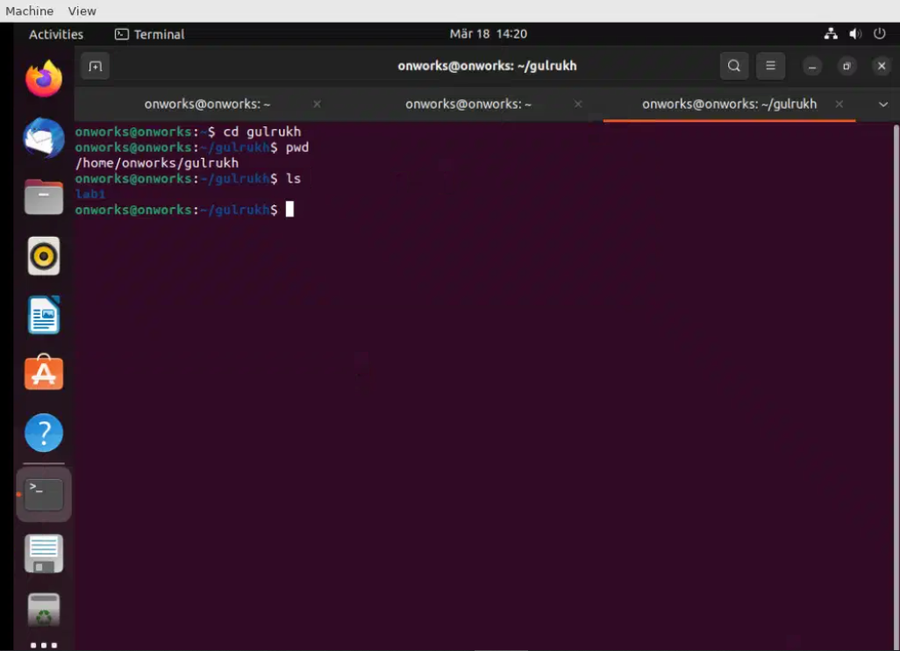

* ***Rmdir (remove directory ):***

